CS 255 System Design Document Template

This template lays out all the different sections that you need to complete for Project Two. Each section has guidance to prompt your thinking. You will need to continually reference the interview transcript as you work to make sure that you are addressing your client’s needs. There is no required length for the final document. Instead the goal is to complete each section based on what your client’s needs are. Remove this note when you are finished, and replace all bracketed text with the relevant information.

UML Diagrams

UML Use Case Diagram
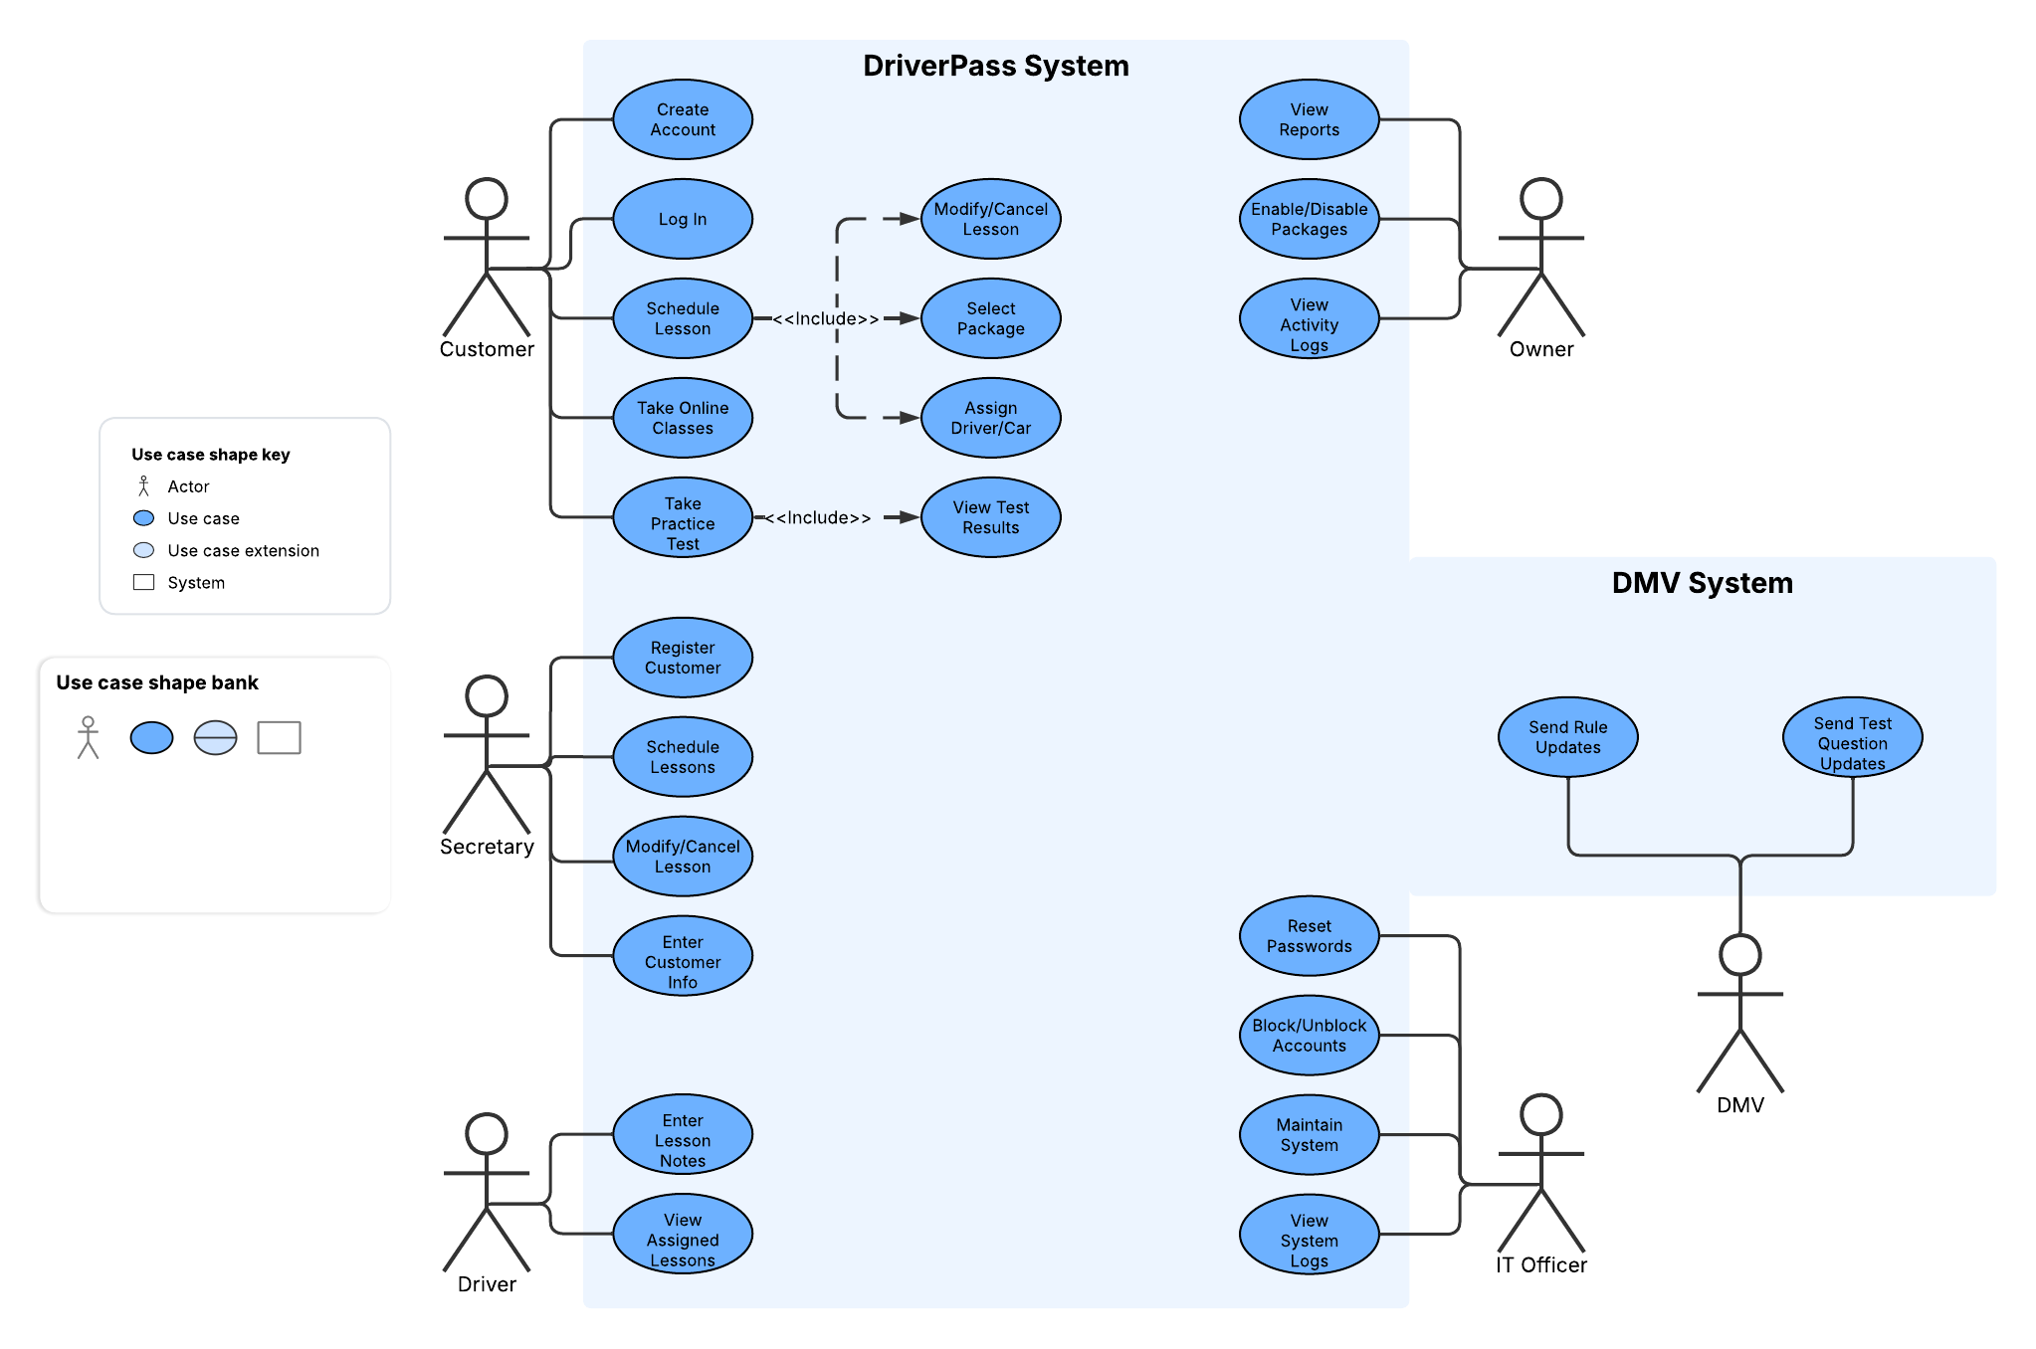

UML Activity Diagrams
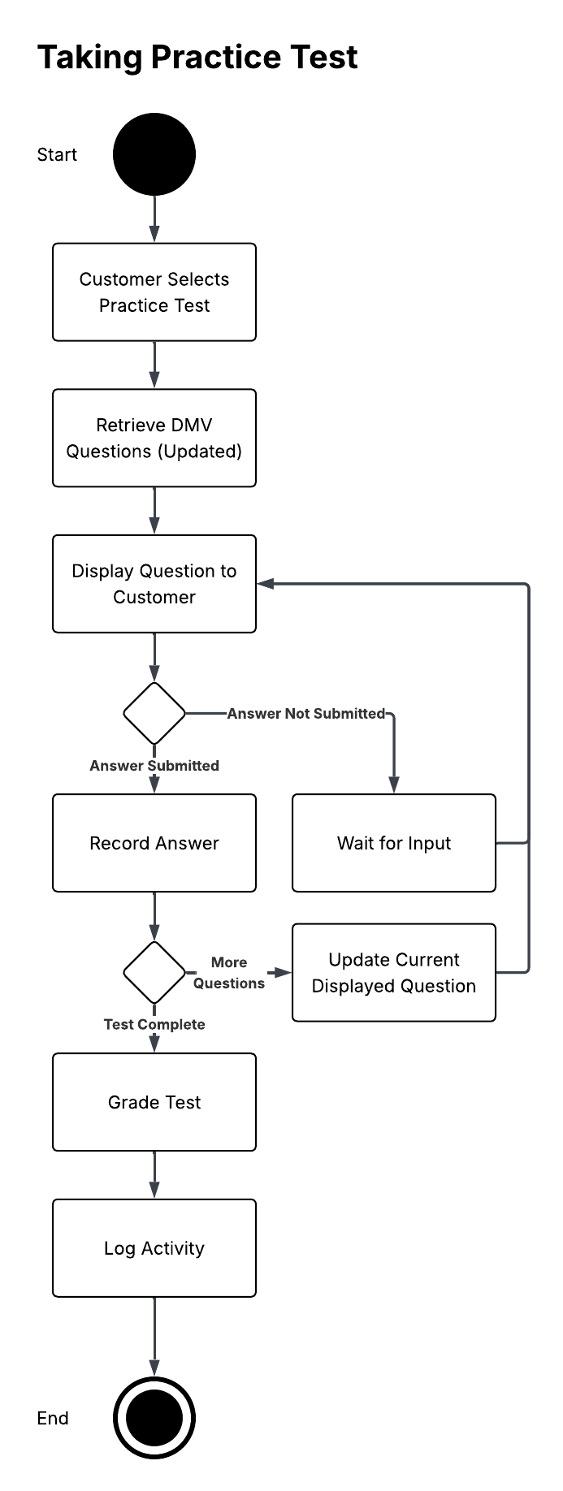
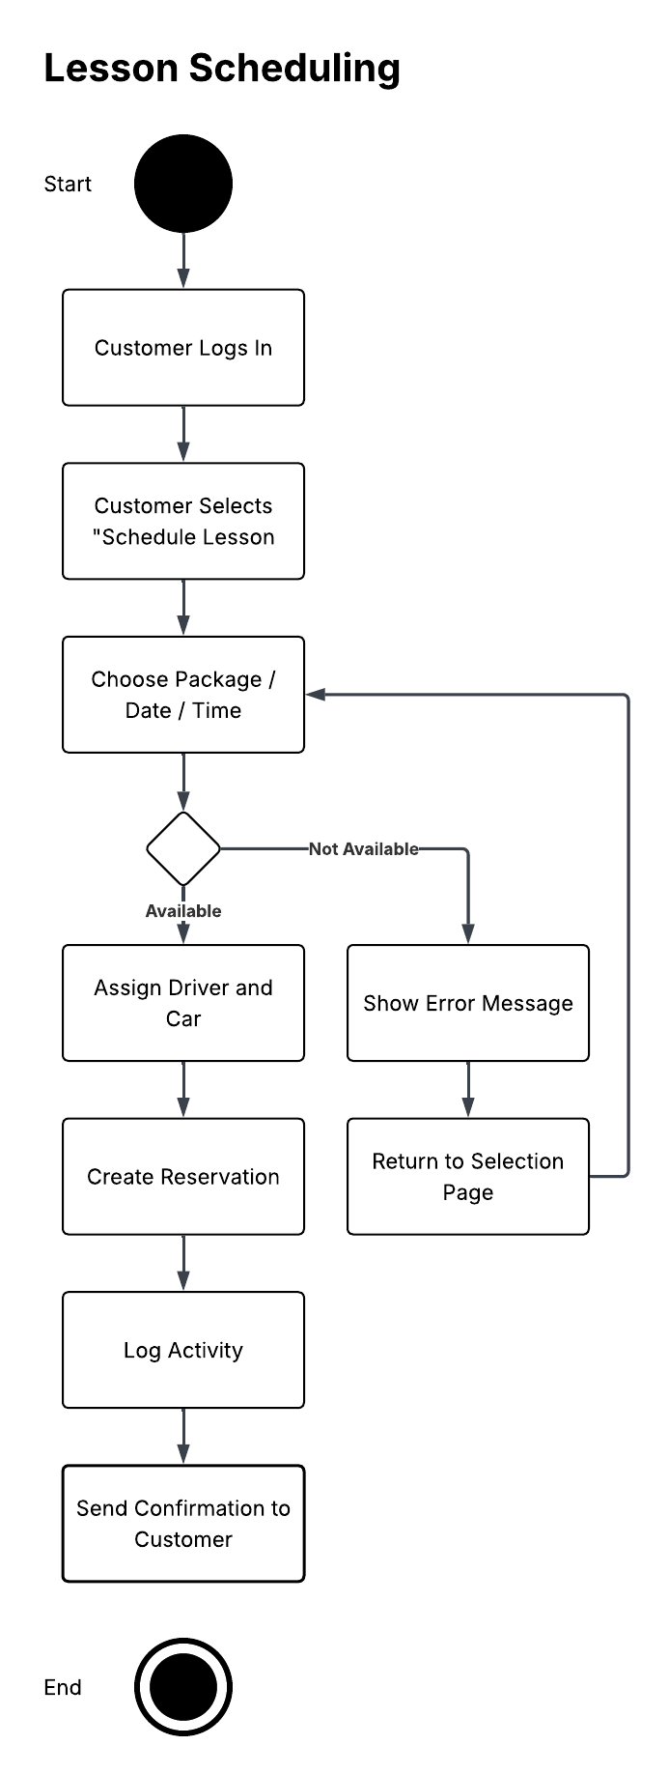

UML Sequence Diagram

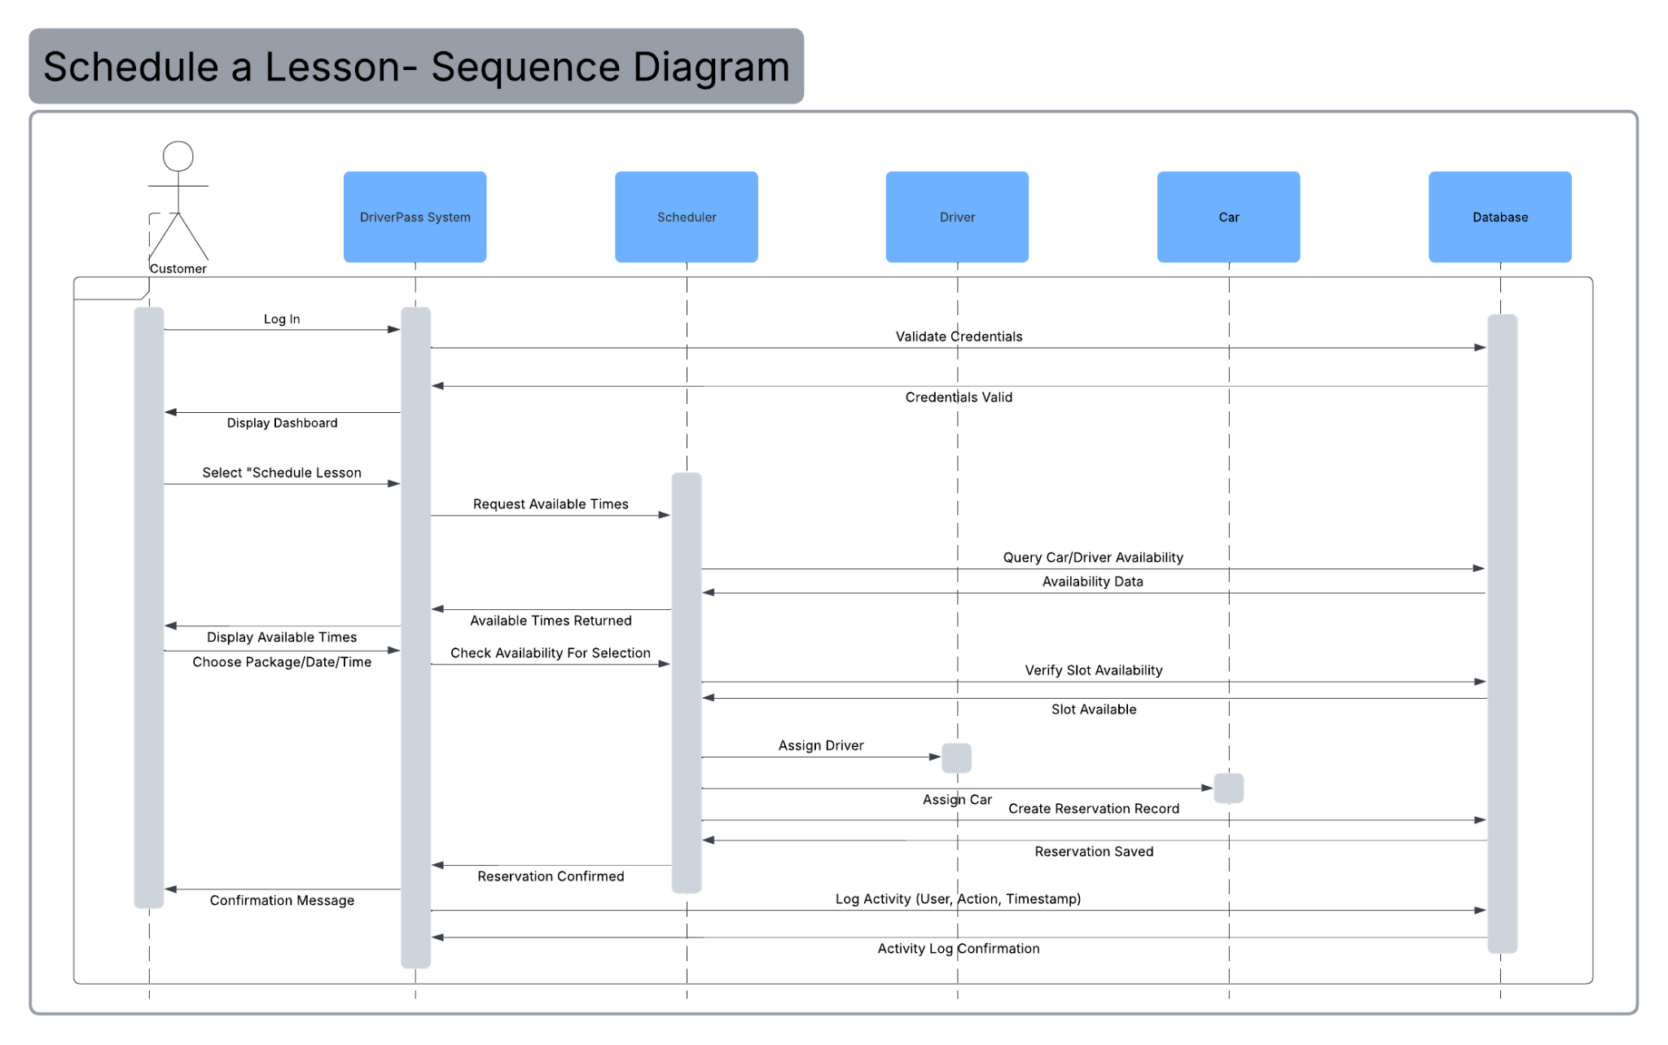

UML Class Diagram
*NOTE*: I was unsure if I should be including relationships (one-to-one, many-to-many, many-to-one) in the class diagram, so I went ahead and did it anyway. Also, I decided to map the methods of the classes for this assignment.

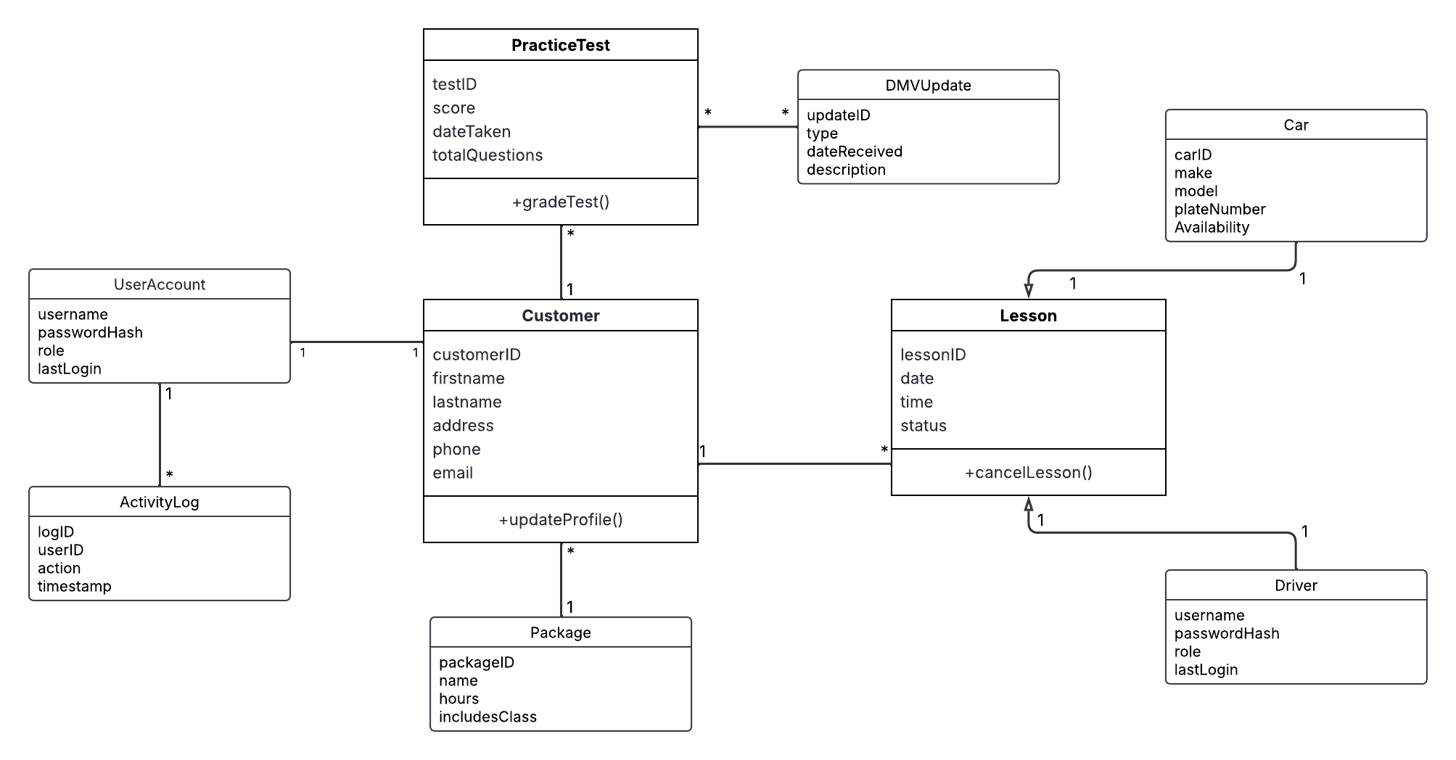

Technical Requirements
The DriverPass system requires a combination of hardware, software, tools, and infrastructure to support all of its possible use cases.
Those requirements are:
Hardware Requirements
- Could-hosted server: DriverPass needs a cloud platform capable of hosting its web application, database and authentication services. This general requirement is broad for any online service
- User Devices: The customers, as well as the staff, both need reliable forms of technology to operate the service, such as desktops, laptops, tablets, or smartphones.
- Office workstations: DriverPass employees responsible for managing and auditing the system will need basic PC workstations in order to do this/
Software Requirements
- Web Application or frontend framework: DriverPass requires some sort of frontend interface that can be viewed on a browser
- Database management: Some form of backend database is needed to store data like user accounts, lessons, packages, test results, and activity logging.
- DMV Integration: The system assumes that the DMV rule updates will be sent in a reliable format
- Logging, monitoring, and authentication systems for security and auditing
Development Requirements
- Version control to manage coordinated development. Could easily be handled by GitHub.
- Lucidchart for system design planning
- Testing tools for validating that the program actually works
Other Requirements
- Secure Communication, to follow industry standard security practices
- Specialized privileged access for various operators, such as IT officers or Secretaries
- Backups and good system maintenance practices
- High system uptime

